**Software Requirements Specification**

**for**

**Health Hub**

**Version 1.0 approved**

**Prepared by: Ali Khizar**

**Talha Shahzad**

**Husnain Ali**

**3rd March, 2024**

**Copyright © 1999 by Karl E. Wiegers. Permission is granted to use, modify, and distribute this document.**

**Software Requirements Specification for <Project> Page 2**

**Table of Contents**

**Table of Contents ii**

**Revision History ii**

1. **Introduction 1**
   1. Purpose 1
   2. Document Conventions 1
   3. Intended Audience and Reading Suggestions 1
   4. Product Scope 1
   5. References 1
2. **Overall Description 2**
   1. Product Perspective 2
   2. Product Functions 2
   3. User Classes and Characteristics 2
   4. Operating Environment 2
   5. Design and Implementation Constraints 2
   6. User Documentation 2
   7. Assumptions and Dependencies 3
3. **External Interface Requirements 3**
   1. User Interfaces 3
   2. Hardware Interfaces 3
   3. Software Interfaces 3
   4. Communications Interfaces 3
4. **System Features 4**
   1. System Feature 1 4
   2. System Feature 2 (and so on) 4
5. **Other Nonfunctional Requirements 4**
   1. Performance Requirements 4
   2. Safety Requirements 5
   3. Security Requirements 5
   4. Software Quality Attributes 5
   5. Business Rules 5
6. **Diagrams 5**
   1. Use Case Diagram 5
   2. Activity Diagram 5
   3. Sequence Diagram 6

**Appendix A: Glossary 6**

**Appendix B: Analysis Models 6**

**Appendix C: To Be Determined List 6**

**Software Requirements Specification for <Project> Page 3**

# 1. Introduction

## 1.1 Purpose

## The purpose of this document is to specify the software requirements for HealthHub version 1.0. HealthHub is a comprehensive healthcare platform aimed at revolutionizing personalized healthcare management. This Software Requirements Specification (SRS) outlines the scope of the product covered in this document, focusing on its key features and functionalities.

# 1.2 Document Conventions

# The SRS follows standard typographical conventions, with requirements prioritized according to their significance in achieving higher-level objectives. Each requirement statement is assigned its own priority to ensure clarity and ease of reference.

# 1.3 Intended Audience and Reading Suggestions

# This document is intended for developers, project managers, marketing staff, users, testers, and documentation writers involved in the development and deployment of HealthHub. It contains an overview of the product's features, detailed functional and non-functional requirements, and specifications for integration with existing healthcare systems. Readers are encouraged to begin with the overview sections and proceed through the sections most pertinent to their roles and responsibilities.

# 1.4 Product Scope

# HealthHub is a groundbreaking healthcare platform designed to transform how individuals manage their well-being and interact with healthcare services. It offers personalized health assessments, telehealth consultations, medical records management, medication adherence and reminders, integration with remote monitoring devices, wellness challenges and incentives, AI-driven health predictions, and health education resources. The software aims to empower users to take charge of their health and promote preventive care strategies.

# 1.5 References

# "HealthHub Vision and Scope Document," Version 1.0, Date: [Insert Date], Source: [Insert Source]

# User Interface Style Guide: [Insert Title, Author, Version Number, Date, Source/Location]

# Contract Documents: [Insert Title, Author, Version Number, Date, Source/Location]

# System Requirements Specifications: [Insert Title, Author, Version Number, Date, Source/Location]

# Use Case Documents: [Insert Title, Author, Version Number, Date, Source/Location]

# These references provide additional context and guidance for the development and implementation of HealthHub.2.

# 

# Overall Description

## 2.1 Product Perspective

## *HealthHub is a standalone product designed to revolutionize personalized healthcare management. It is a new, self-contained platform developed to address the growing need for comprehensive and user-centric healthcare solutions. While HealthHub may integrate with existing healthcare systems through APIs and data exchange protocols, it primarily functions as an independent entity.*

## 2.2 Product Functions

## *Personalized health assessments*

## *Telehealth consultations*

## *Medical records management*

## *Medication adherence and reminders*

## *Integration with remote monitoring devices*

## *Wellness challenges and incentives*

## *AI-driven health predictions*

## *Health education resources*

## 2.3 User Classes and Characteristics

## *HealthHub is intended for various user classes, including:*

## *Individuals seeking personalized healthcare management*

## *Healthcare professionals providing telehealth consultations and accessing patient data*

## *Administrators managing system configurations and user accounts*

## *Users may vary in technical expertise, with healthcare professionals requiring advanced knowledge of medical practices and individuals requiring user-friendly interfaces for easy navigation.*

## 2.4 Operating Environment

## *HealthHub operates in a diverse environment, compatible with:*

## *Web browsers (Chrome, Firefox, Safari)*

## *Mobile devices (iOS, Android)*

## *Desktop computers (Windows, macOS)*

## *Internet connectivity for real-time data exchange*

## 2.5 Design and Implementation Constraints

## *Compliance with regulatory standards (HIPAA, GDPR)*

## *Compatibility with existing healthcare systems through standardized APIs*

## *Use of secure encryption protocols to safeguard sensitive health data*

## *Adoption of scalable architecture to accommodate future growth and expansion*

## 2.6 User Documentation

User documentation components for HealthHub include:

User manuals

Online help resources

Tutorials and video guides

These components will be delivered in digital formats accessible through the HealthHub platform.

## 2.7 Assumptions and Dependencies

# *Assumption: Integration with third-party healthcare providers' systems will be feasible through standardized APIs.*

# *Dependency: Availability of remote monitoring devices compatible with HealthHub's data integration protocols.*

# *Assumption: Users will have access to reliable internet connections for telehealth consultations and data synchronization.*

# *Dependency: Compliance with regulatory requirements and data privacy laws in all regions of operation.*

# 3. External Interface Requirements

## 3.1 User Interfaces

## *The user interface of HealthHub is designed to be intuitive, user-friendly, and visually appealing. Key characteristics of the user interface include:*

## *Sample screen images depicting various features and functionalities.*

## *Compliance with GUI standards and accessibility guidelines.*

## *Consistent screen layout across different devices (mobile, desktop).*

## *Standard buttons and functions (e.g., help, settings) accessible from every screen.*

## *Error message display standards ensuring clarity and helpfulness.*

## *Keyboard shortcuts for common actions to enhance user efficiency.*

## *Detailed design specifications for the user interface are documented in a separate User Interface Specification document.*

## 3.2 Hardware Interfaces

## *HealthHub interacts with various hardware components, including:*

## *Supported device types: Mobile devices (iOS, Android), desktop computers (Windows, macOS).*

## *Nature of data and control interactions: Data synchronization between the software and remote monitoring devices via Bluetooth or Wi-Fi.*

## *Communication protocols: Bluetooth Low Energy (BLE), Wi-Fi Direct, USB for device connectivity.*

## *Physical characteristics of hardware interfaces ensure seamless integration and data exchange between HealthHub and external devices.*

## 3.3 Software Interfaces

## *HealthHub integrates with several software components, including:*

## *Database systems: MySQL for data storage and retrieval.*

## *Operating systems: Compatibility with Windows, macOS, iOS, Android.*

## *Tools and libraries: Use of machine learning libraries for personalized health assessments.*

## *Integrated commercial components: Integration with third-party telehealth platforms for virtual consultations.*

## *Data items shared across software components include user profiles, medical records, and health analytics. Detailed application programming interface (API) protocols are documented separately to ensure seamless integration and interoperability.*

## 3.4 Communications Interfaces

HealthHub requires various communications functions, including:

Email: Sending notifications and alerts to users.

Web browser: Accessing the HealthHub platform from web browsers.

Network server communications protocols: HTTP for web-based interactions.

Electronic forms: Data collection for personalized health assessments.

Message formatting: JSON for data exchange between client and server.

Communication security: SSL/TLS encryption to ensure data security during transmission.

Data transfer rates and synchronization mechanisms: Real-time data synchronization for remote monitoring devices, ensuring up-to-date health information for users.

Communication standards and encryption mechanisms are implemented to safeguard user data and ensure secure communication channels.

# 4. System Features

<This template illustrates organizing the functional requirements for the product by system features, the major services provided by the product. You may prefer to organize this section by use case, mode of operation, user class, object class, functional hierarchy, or combinations of these, whatever makes the most logical sense for your product.>

**4.1 Personalized Health Assessments**

**4.1.1 View Health Analytics**

**Description and Priority:**

This feature allows users to view their health analytics, including health status, risk factors, and recommendations. Priority: High.

**Stimulus/Response Sequences:**

Stimulus: User opens the health assessment menu.

Response: System displays options for viewing health analytics in a human-readable format.

**Functional Requirements:**

REQ-1: Display all health-related options clearly and comprehensively.

REQ-2: Ensure the presented data is understandable and relevant to the user's well-being.

**4.1.2 Receive Health Status and Risk Factor**

**Description and Priority:**

This feature enables users to receive their health status, risk factors, and personalized recommendations based on their data. Priority: High.

**Stimulus/Response Sequences:**

Stimulus: User accesses the health analytics option and fills in required data.

Response: System displays the user's health stats, risk factors, and recommendations in a visualized format.

**Functional Requirements:**

REQ-3: Provide users with clear visual representations of their health stats and risk factors.

REQ-4: Validate user-input data and display error messages for incorrect inputs.

**4.1.3 Get Recommendations**

**Description and Priority:**

This feature allows users to request personalized proactive recommendations based on their health stats. Priority: Medium.

**Stimulus/Response Sequences:**

Stimulus: User accesses the health analytics options and requests recommendations.

Response: System performs data analysis and provides personalized recommendations.

**Functional Requirements:**

REQ-5: Implement algorithms for analyzing user data and generating personalized recommendations.

REQ-6: Ensure recommendations are relevant and actionable for the user's health improvement.

**4.2 Virtual Consultations through Telehealth**

**4.2.1 Access Healthcare Professionals**

**Description and Priority:**

This feature enables users to access healthcare professionals through telehealth for virtual consultations. Priority: High.

**Stimulus/Response Sequences:**

Stimulus: User selects the telehealth feature.

Response: System displays a list of healthcare professionals with their contact information.

**Functional Requirements:**

REQ-7: Integrate a database of healthcare professionals accessible through the telehealth feature.

REQ-8: Display relevant contact information for each healthcare professional listed.

**4.2.2 Schedule Virtual Consultations**

**Description and Priority:**

This feature allows users to schedule virtual consultations with healthcare professionals through the HealthHub platform. Priority: High.

**Stimulus/Response Sequences:**

Stimulus: User selects a desired time slot for consultation.

Response: System confirms the appointment and notifies the user.

**Functional Requirements:**

REQ-9: Provide users with an interface to schedule appointments with healthcare professionals.

REQ-10: Send confirmation notifications to users upon successful appointment booking.

# 5. Other Nonfunctional Requirements

# 5.1 Performance Requirements

# Performance Requirement 1:

# Description: The system should respond to user actions within 2 seconds under normal load conditions.

# Rationale: This ensures a responsive user experience and prevents frustration due to long wait times.

# Performance Requirement 2:

# Description: The system should be able to handle concurrent virtual consultations for up to 1000 users without significant degradation in performance.

# Rationale: This ensures the system can scale effectively to accommodate a large user base.

# 5.2 Safety Requirements

# Safety Requirement 1:

# Description: The system must comply with HIPAA regulations to ensure the privacy and security of patient health information.

# Rationale: Protecting patient confidentiality and data security is critical in healthcare applications to prevent unauthorized access and breaches.

# 5.3 Security Requirements

# Security Requirement 1:

# Description: User authentication must be performed using strong encryption protocols such as HTTPS for data transmission.

# Rationale: Ensures secure communication between the user's device and the HealthHub servers, preventing unauthorized access to sensitive information.

# 5.4 Software Quality Attributes

# Software Quality Attribute 1: Usability:

# Description: The system should provide an intuitive user interface with clear navigation and understandable terminology.

# Rationale: Enhances user satisfaction and adoption rates by making the system easy to use and navigate.

# Software Quality Attribute 2: Reliability:

# Description: The system should have a 99.9% uptime, ensuring users can access critical features without interruptions.

# Rationale: Maintains user trust and confidence in the system's reliability for accessing healthcare services.

# 5.5 Business Rules

# Business Rule 1:

# Description: Only authorized healthcare professionals should have access to patients' medical records and be able to prescribe treatments.

# Implication: Requires implementing user authentication and role-based access control to enforce access restrictions.

# 6. Diagrams

**6.1 Use Case Diagram**

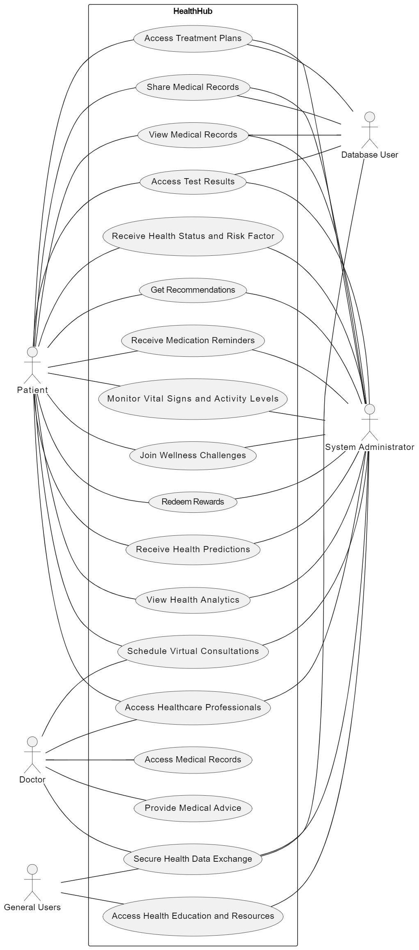

**6.2 Activity Diagram**

## 

## 6.3 Sequence Diagram

**System Diagrams:**

1. Access Treatment plans:

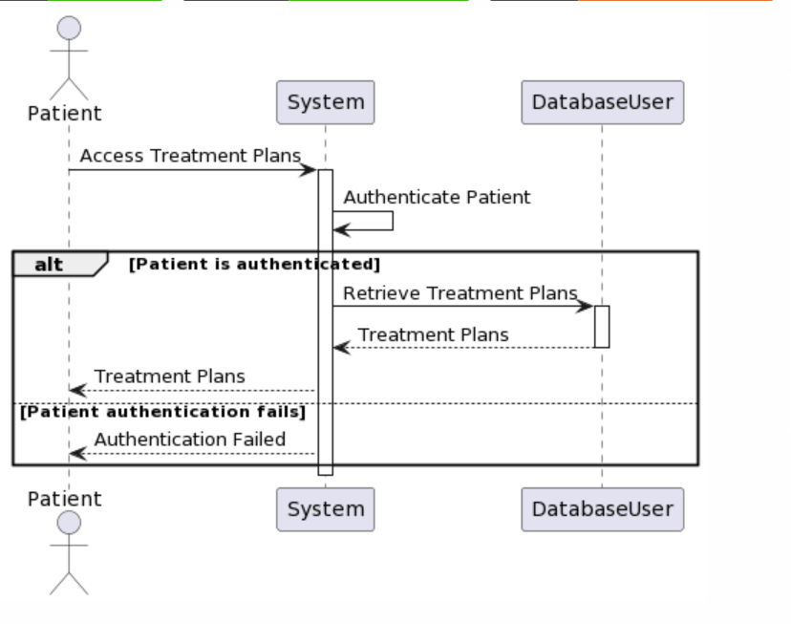

1. Share Medical Records:

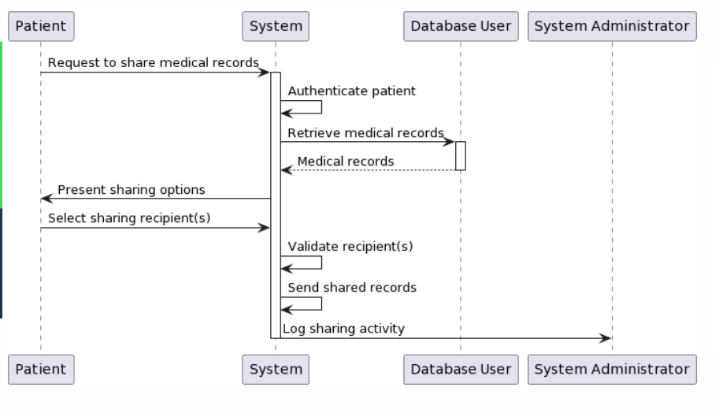

1. View Medical Records:

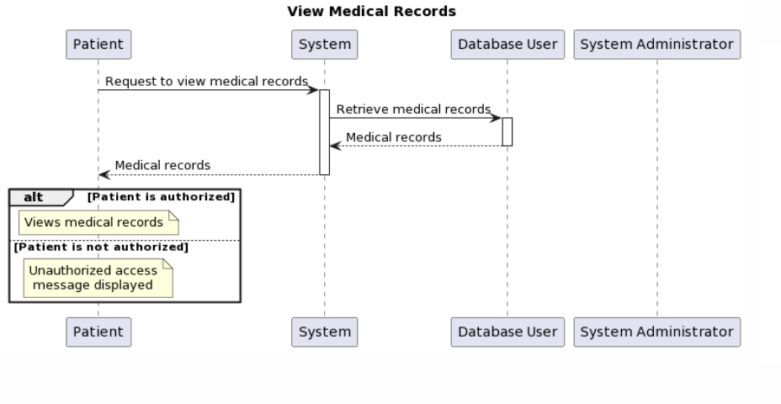

1. Access Test Results:

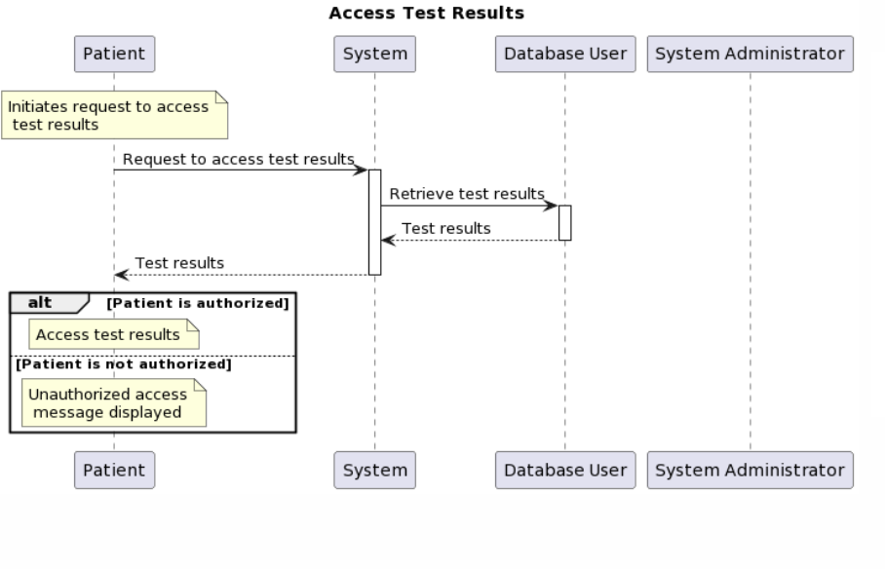

1. Receive Health Status and Risk Factor:

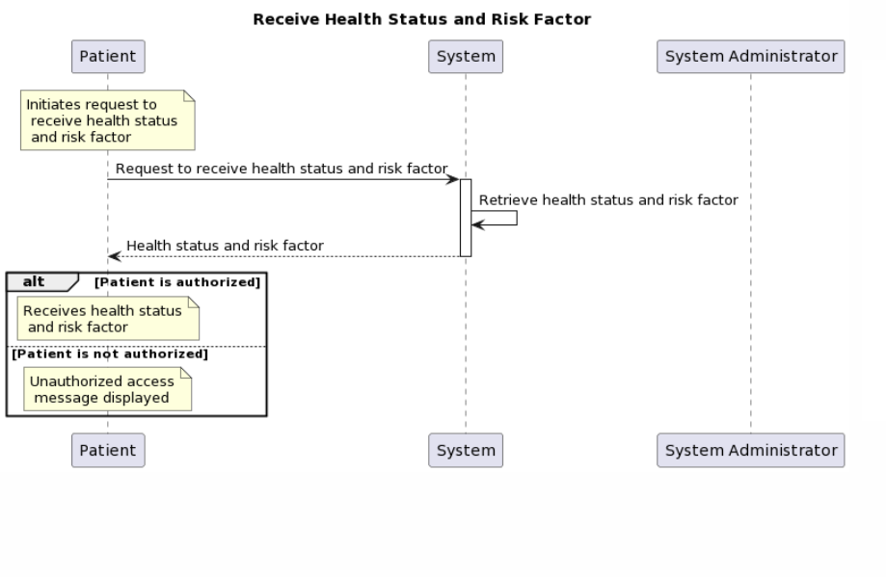

1. Get Recommendations:

1. Receive Medication Reminders:

1. Join Wellness Challenges:

1. Receive Health Predictions:

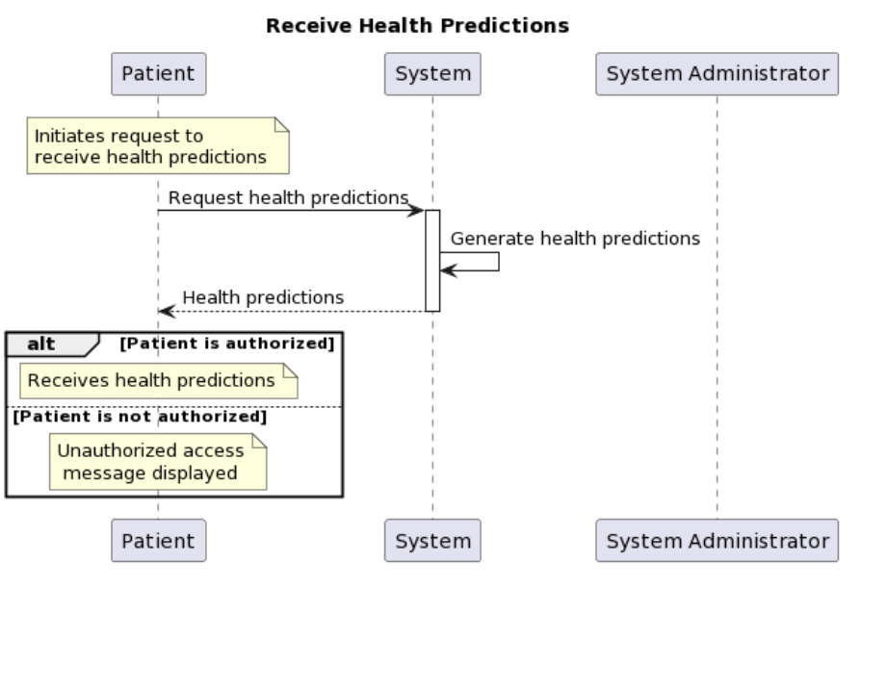

1. Schedule Virtual Consultations:

1. Access Healthcare Professionals:

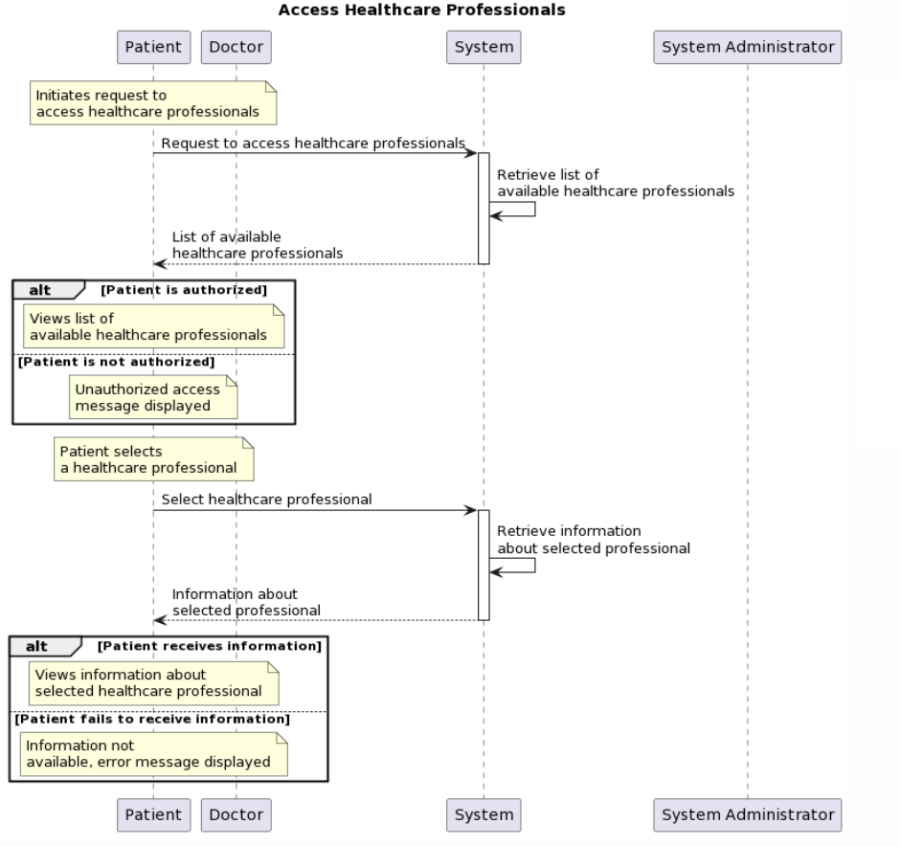

1. Secure Health Data Exchange:

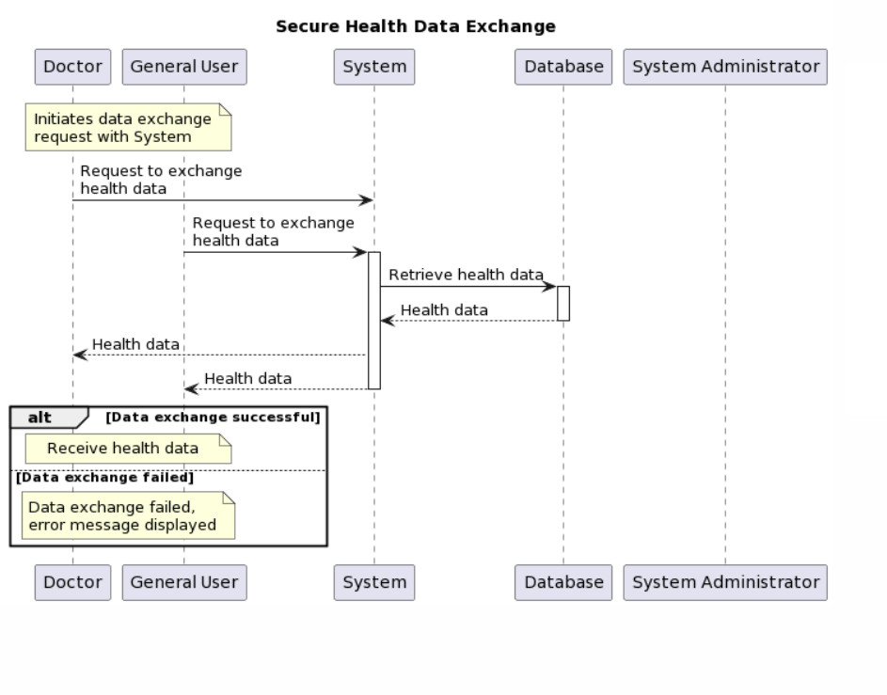

1. Access Health Education and Resources:

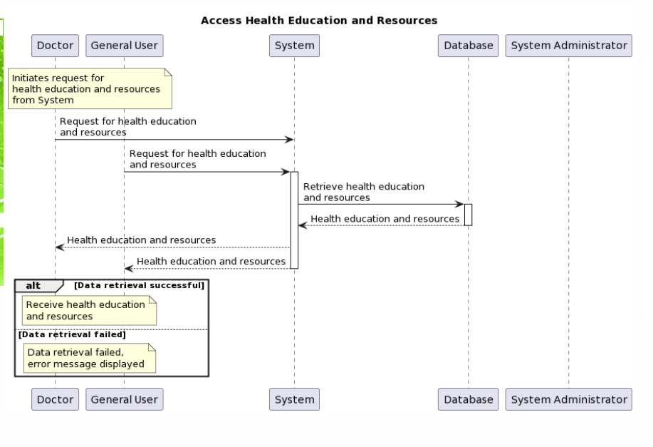

# Appendix A: Glossary

<Define all the terms necessary to properly interpret the SRS, including acronyms and abbreviations. You may wish to build a separate glossary that spans multiple projects or the entire organization, and just include terms specific to a single project in each SRS.>

# Appendix B: Analysis Models

<Optionally, include any pertinent analysis models, such as data flow diagrams, class diagrams, state-transition diagrams, or entity-relationship diagrams.>

# Appendix C: To Be Determined List

<Collect a numbered list of the TBD (to be determined) references that remain in the SRS so they can be tracked to closure.>